**CHAPTER ONE**

**INTRODUCTION**

## 1.1BACKGROUND OF STUDY

Online New Born Birth Certificate System(ONBBCS) is the official recording of the birth of a child by a state administrative process of the country, and coordinated by a particular branch of government. Lalitha and Ameerah (2015). It is the permanent and official record of a child’s existence and is fundamental to the realization of children’s rights and practical needs. Securing children’s rights to a nationality will allow them to get a passport, open a bank account, vote and find employment. It helps ensure access to basic services, including immunization, health care and school enrolment at the right age. At present it is estimated that millions of Zimbabwean children are not being registered at birth, meaning that these children are being denied the right to a name and nationality, a situation that may also lead to barriers in accessing other rights including health care and education.

One important area where data collection is essential on human population is vital registration; which according to Lalitha and Ameerah (2015) is “the continuous, permanent, compulsory and universal recording of the occurrence and characteristics of vital events pertaining to the population as provided through decree or regulation in accordance with the legal requirements of a country.” collecting data on human population is, therefore, a complex series of related activities. There is no gainsaying the fact that accurate population statistics is vital to sound development planning and economic management. This explains the seriousness attached to the assemblage of population and vital statistics in the country today. Apart from the information on the stock of country’s population, it is essential to know the rate at which the population is changing, structurally and in the aggregate. Vital statistics as computable from registration of important events (especially births and deaths), constitute an important set of data for studying the dynamics of a country’s population.

According to Zubema (2008), the Department of Registrar General is one of the core department of the National Population Commission mandated to undertake the continuous and compulsory registration of Births in Zimbabwe, through an Act titled “Births, deaths, etc for the national population planning and for estimating the number of children that is born into the country every year.‟ (Compulsory) Registration no 69 of 1992 dated 14th December, 1992. (The Registration of Births and Deaths Act, (1969)), this act empowers the Commission to register such vital events nationwide. The Act clearly spelt out the registration hierarchy, responsibilities, and establishment of centers, procedure for Registration, time limit for registration and documentation of vital events such as, Births, Deaths Stillbirths, Marriage, Divorces, and the penalties for various offences among other issues. The authority is given to the Commission to perform these statutory functions of Registrations of birth and death in every locality, Local Government Area (LGA) and State of Zimbabwe. The Data collected can therefore be processed and analyzed for government to use for planning and also as a data source to other research bodies, non-governmental bodies and also agencies that require such data.

## 1.2 STATEMENT OF THE PROBLEM

There is much wastage oftime andmoney becauseofmanual registration, ittakesalong processforsomeonetoget a birth certificate. Theyaresomanycomplains whichare filed becauseoflong queues and the slowness of the process usinghumaneffort.

## 1.3 OBJECTIVES

1. Toprovideonline birth certificate registration ofnewly born babiessothattheywill beadigitalrepositorycontaining children
2. to notify birth applicants about their applications through email.

## 1.4 HYPOTHESIS

Anumberofsolutions can be employed tothecurrentsystemasfollows:

H0:Online New Born Birth Certificate System

H1(a):To buy a system for newly born birth certificate

OftheabovealternativesOnline New Born Birth Certificate Systemisthebestmoremodernalternate.

Ifpartiallyautomated,thesystemwillbeflexiblyableto retrieve,updateinformationandstatus quickly, whenrequired without taking much time.Userswill beabletoapply,to view application statusfromanyangleofthecountry.

## 1.5 JUSTIFICATION

The significance of this project work is to proffer solutions to current backdrops experienced in the registration of birth thereby fostering a more effective and efficient data collection, storage, processing and retrieval method. This project would also provide a means for nation planning and population forecasting.

## 1.6 CONCLUSION

Online New Born Birth Certificate Systemisthebesttoovercome problems asithasbeenintroduced,thereisa greatneed foranothersystemastheproblems arecausing long queues,delay inregistration andunfair distribution, and the objectivesofthe proposed system arewell explained and justifiable. Hoping thatthelimitations ofthisstudywill notaffecttheresearchandthenext phaseisthedesignphase.

**CHAPTER 2: PLANNING PHASE**

**2.1 Introduction**

Having undergone project proposal, one looks at the planning phase and certain critical factors have to be taken into consideration. This include the reason why the project is undertaken based on the objectives of the project and problems of the current system at hand which were identified and mentioned in the proposal. Also it can be established if project can be successfully be undertaken by the resources available and this can be justified by undertaking a feasibility study.

**2.2 Why build the system**

* + - * NEW BORN BIRTH CERTIFICATE SYSTEM**–** the proposed solution requires the expertise of a Visual Basic Programmer.
      * Major Software Requirements Already Available – Marondera Registra already has Visual Basic 6.0 and Microsoft Access 2000 in its possession. And the other tools needed are all freely downloaded from the internet. The only missing software is Crystal Reports that is modestly priced. Thus software acquisitions cost are minimal.
      * Top Management Support – with the top management for Marondera Registra pushing for this project, budget issues and resources are not going to be a problem.
      * What the system will do **-** Capturing child details, printing: (receipts, prescriptions, billing statements, child personal medication details), Verification and Validation and Backup, which is unlike the manual system.

**2.3 Business value**

Business values refer to the success of the organization in using information to achieve its strategic objectives. This is the part of the corporate strategy, comprises the development and declaration of shared view of business’ direction and the benefits to be entailed overall from the business perspective. The focus of this section is to identify the business value of the system that I intend to develop. It should also cater for an increase in the number of childs’ served by the hospital.

In short, the organisation should not suffer loss when it adopts the finished system. Therefore, the new system is supposed to make-work easier.

The system is going to be of great value to the company in the following ways:

Single birth certificate Database/ Easy sharing of resources

An integrated package enables the seamless sharing of child information across all of the applications. Child Records and inventory all use a single database, so information entered in one application is immediately available everywhere. For example, once a new born child applied for a birth certificate online it reflects to all provinces that the child applied.“First, it reduces redundant data entry, saving us a lot of time. Secondly, it eliminates errors and inconsistencies from having to enter child information twice.

**Proved services**

* Faster and more accurate in provision of information and services thus reducing time for enquiries and child waiting period.
* Ensures speed processing transactions such as those of medication billing calculations.
* Quick scheduling.

Ability to handle large volumes of work

* A computerized system will have the ability to cope with large volumes of files and records and there are no space problems unlike as in the manual system, the billing statements will be processed in bulk.

There will be accurate and consistent recording and better-input method of child details with minimal errors

* The new system will have the facility for double-checking any record entered such as amend, retrieve and delete. Message box will appear before any postings are made, this allows the user to make user that his figures and details are the correct record before it is posted.

Better management control

* Ability to service childs much faster without manipulation of the data for personal use. This will facilitate unbiased reports for management.
* Also decision making will be easier because management reports will be produced when and wherever they are wanted for example if the registra want to know the number of new born listing for the month, he will just query the database which takes less time.

**2.4** **Feasibility Study**

**2.4.1 Technical feasibility**

This answers the question as to whether the system can be built given the apparent constraints in terms of resources and time amongst many others. It encompasses the ability to use up-to-date technology such as the new and more powerful computers, whether the identified user needs may be satisfied using current software or hardware. The success of this analysis also depends on whether the staff is willing to undergo training and is not resistant to change.

New Born Birth certificate

Considering the resources at hand I can build the new system. Marondera Registra has the full and technically competent. An in house database administrator will be trained and will be working at Marondera Registra. The researcher opted for Visual Basic Version 6.0 because it is cheaper and easy to get on the market hence this will cut down costs. Considering that almost all the technical that are needed are available the researcher believes that the technical aspects will be met.

**2.4.2 Economic feasibility**

This feasibility study is usually the bottom line in many projects. It answers the question ‘should the system be built’ and if it were built, would there be ready finance to cover it. This will also encompass all the costs that will be associated with the process of actually building the new system. Economic feasibility is defined as Cost-Benefit Analysis, which measures the financial impact of the project. With Marondera Registra it has all the required software and hardware and money for labour hence development will be easier.

**Interpretation of the Cost-Benefit Analysis**

**Development costs**

Development costs these are incurred only once at the time the system is developed. i.e. they can estimate from the onset of a project and should be refined at the end of each phase of the project. These development costs include:

* Personnel Costs
* Training
* Supply, duplication and equipment costs
* Cost of new computer equipment and software

**Operational Costs**

These tend to occur throughout the lifetime of the system. For example system maintenance costs. They can be classified as Fixed and Variable Costs.

Fixed costs occur at regular intervals but at relatively fixed rates. For example lease payments, software license payments.

Variable costs occur in proportion to some usage factor. For example supplies such as that of compact disks, magnetic tapes, printer paper and prorated overhead costs.

**Table 2.1: Cost benefit analysis projection**

From the above figure 2.1 analysis tables for the Cost- Benefit the first year-to-year end period are going the produce positive benefits. It therefore can be concluded that the proposed project is economically feasible.

#### Return on Investment Analysis (ROI)

This is defined as a financial measure of the return from an investment. Usually this is defined as a financial measure of the return from an investment usually expressed as a percentage of earnings produced by an asset to the amount invested in the asset. The annual return on investment is calculated as follows:

ROI = (Total Benefits - Total Costs) * 100 %

Total Costs

ROI = (800 - 550) * 100 %

550

= 45.45 %

#### Comments

This solution was compared to alternative solutions and it yielded the best ROI. From the ROI analysis the project is viable.

## *Risk Analysis*

### These phases identifies, evaluates, and try to come up with solutions on things that might go wrong in the project before it becomes a threat to the successful completion of the project or implementation of the Proposed System. The below Risk Analysis Log is also supported by the technical, economical and any other risks that are associated with the implementation of the new proposed system. The logs analyze and recommend so as reducing the chances of jeopardizing the new system and any other jobs associated with the implementation.

### 

### Risk analysis Log

|  |  |  |  |  |
| --- | --- | --- | --- | --- |
| Ref | Risk Statement | Probability of Occurrence | Impact (if risk occurs) | Preventive/Contingence Action |
| 1 | Inadequate in house resources | Low | -Failure to cope with the demands of the project needs such as new hardware and software  -Under delivery due to doubling up on project and business as usual (BAU) responsibilities | * Action to advice the head office of the supplementary budget in case Reliant Computers fails to supply the project needs. * To halt developments on old system and attend to problems only |
| 2 | Inadequate in house project management, execution and technical skills | Low | -Prolonged learning curve  -Staff turnover resulting in technically trained people leaving | * Promote peer to peer training /discussions to share knowledge * Identify required training and provide adequate training to all project team members |
| 4 | Failure to project deliverables to meet specifications  (over fulfillment or under fulfillments of requirements) | Medium | -Failure by developers to deliver according to specification will delay the project go live and increase costs | * Maintain and monitor a checklist of all deliverables * Maintain an issues log and chase issues for closure * Nurture a coherent joint team relationship of in-house participants and developers |
| 6 | Key resources on the project not available | Low | -Disruption of project progress and failure to meet deadlines | * Advance planning of unavoidable but foreseeable unavailability of resources |

**Table 2.2 Risk Analysis log**

### Other Risks

##### *Users*

* The other risk that the system might face is that the users might have the impression that it may be too challenging and in this case they may risk loosing their jobs. There will be need to restore confidence in the users otherwise the system will be bound to fail due to sabotage. With the Chitungwiza General proposed system no jobs are threatened as the staff is government employed instead job opportunities are likely to increase and users will be informed that the new system will not jeopardize any one of their jobs.

##### *Technical Risks*

* There is a risk that the system may not meet the user’s expectations in terms of the user interface considering that the users would have used different types of systems with differing interfaces.
* The users might find it difficult to maintain the system or restore it in the event of a crush. It being a new system, it will need to be backed up and fully supported. Once the system has been implemented, there would be support for the system and maintenance of the proposed system in the first couple of months till the system is in them and they can fully operate it independently.
* Deployment of the system is going to require the use of parallel conversion in implementation of the new system. The two systems will operate at the same time for a short duration of time just until the risk of failure or difficulty for new system is cushioned, especially the accounting side so as to avoid errors of omission and if already done be able to refer to manual process. The technical risks would be of no further importance considering that there is a fall-back plan in case the new system fails to deliver.

##### *Economic Risks*

* Costs of hardware and software, which keep escalating can jeopardize the project and may actually be at the risk of termination. If the organization really needs the system, it has to budget for it to avoid shortfalls in the development process. All the resources must be readily available and fully functional. The risk is thus avoided by the allocation of a supplementary budget for the system in the event of prices continuing to escalate.

### Tangible benefits and Intangible benefits

**Tangible benefits include:**

* Decreased response time
* Elimination of job steps
* Reduced stationery expenses
* Fast processing and printing of medication billing records and reports
* Reduced time of enquiring
* Reduced work overload

**Intangible benefits include**:

* Improved childs goodwill
* Improved employee morals
* Improved job satisfaction
* Better customer services
* Improved quality of information
* Better decision making by management

### 2.4.4 Operational Feasibility

Here I am looking at how operational is the system, do I have the technical staff that will meet the projects requirements. It also looks at how the system is going to affect the stakeholders in the organization and whether it will receive the full support of the management. It also analyzes whether the system will risk the jobs of the employees or rather whether it will increase the employee opportunities. There will be need to train the users when the system is completed but there will also be a help file attached to the system so that the users can consult it on issues that would be requiring clarity.

**Operational feasibility depends on:**

* Management and user support
* User involvement in planning

After evaluation of operational feasibility, I realized that I can operate the new system. I have the technical expertise the project requirements. In cases of emergency backup project team will be put at stand-by. Stakeholders in the organization have been identified and their objectives have also been put into consideration before the final objectives have been passed. The system is receiving full support of the stakeholders as they feel that the current system in place is rather costly to the head office and not really beneficial to customers as it is meant to be.

I also analyzed looked into the employees’ risk of losing jobs. However, in any case the new system is increasing employee opportunities. Training will be carried out on every module of the system once it has been fully completed and a user manual and help file will be attached to the system so that users can consult on issues requiring clarity. Marondera Registra proposed system is therefore operationally feasible.

### Feasibility Study Conclusion

After analysing the feasibility of the proposed system recommendations Ire passed to go ahead with the development of the proposed system. The benefits outweigh costs and within a year.

## *2.5 Work Plan*

This also shows the time taken to complete the project. The time is expressed in terms of weeks. Each phase has the start time and the completion date. The proposed project starts on the 1st of February 2020 and ends at the 20th of April 2020 thus after 9 weeks.

The Systems Development Life Cycle shall be used to model the activities that are going to be followed in the system development of the project.

* This model has been chosen over other models, since it is a well-documented and widely used approach.
* This is a linear approach involving the stages that are clearly defined at each stage.
* This approach clearly distinguishes the task break down of all tasks to be done, example being feasibility, analysis, design, coding, testing and maintenance.
* Each phase is given a time allocation from the beginning to the end of the project.
* Targets are easy to set with this approach, and one knows exactly what needs to be done from which period of time.
* There is an elaborately written documentation at each phase, this helps in developing a well-documentedsystem.

### The table below shows the project time allocation schedule.

|  |  |  |  |
| --- | --- | --- | --- |
| **Phase** | **Start** | **End** | **Duration** |
| Proposal | 01/02/2020 | 08/02/2020 | 7 |
| Planning | 09/02/2020 | 23/02/2020 | 14 |
| Analysis | 24/02/2020 | 07/03/2020 | 14 |
| Design | 08/03/2020 | 22/03/2020 | 14 |
| Implementation | 23/03/2020 | 30/03/2020 | 7 |
| Maintenance | 31/04/2020 | 06/04/2020 | 7 |

Dates

**Table 2.3: The projected time scheduling.**

### 2.5.3 Time Plan Gantt chart

The diagram below shows the Gantt chart of the system

It shows the time taken to carry out the activities, which are grouped into different phases. The phrases are carried in weeks as shown below.

|  |  |  |  |  |  |  |  |  |  |
| --- | --- | --- | --- | --- | --- | --- | --- | --- | --- |
| **ACTIVITY** | **1 WK** | **2 WKS** | | **2 WKS** | | **3 WKS** | | **4 WKS** | **5 WKS** |
| Project proposal |  |  |  |  |  |  |  |  |  |
| Planning |  |  |  |  |  |  |  |  |  |
| Analysis |  |  |  |  |  |  |  |  |  |
| Design |  |  |  |  |  |  |  |  |  |
| Implementation |  |  |  |  |  |  |  |  |  |
| Maintenance |  |  |  |  |  |  |  |  |  |
| Documentation |  |  |  |  |  |  |  |  |  |

### Table 2.4: Gantt Chart of the project

### 2.5.4 Project size

The project size should be moderate. The system to be designed should be fairly understood so as to avoid complexities. In this case the (project) proposed system is small and manageable and encompasses on few modules.

### 2.6 Conclusion

The project is quite feasible according to the feasibility study as well as the time frame given. After this stage the next phase of systems development that follows is Analysis of the current system where information will be gathered to find how it is working.

## *CHAPTER 3: ANALYSIS PHASE*

## *3.1 Introduction*

The analysis phase seeks to answer the following question, “What does the system do?” This mainly involves the requirements that the system tries to meet. At the end of the day the deliverable of the analysis phase is the requirements documentation. The main purpose of the analysis phase is therefore to bring all those pieces together to form a logical database model or system containing all entities and their attributes, domain relationships, together with a complete functioning model with its hierarchy, and domain constraints (on attribute), business rules (constraints) and events that trigger functions. The scope here is therefore, “What is to be made, and not how?” It is all about the business and not the system.

## *3.2 Information Gathering Methodologies*

For this project three data gathering methodologies were used. However, each of these methods had its own strengths and weaknesses as far as gathering data for this project is concerned. The analyst used questionnaires, observation, and document review. This was done so that the most appropriate method will be chosen. Each of these methods has its own strength and a weakness as far as data-gathering methodologies is concerned. When these three methods combined are different but they mutually support the collection of data and also they give light to the project being carried out. In addition, they also assist the analyst in giving clear picture of the system’s problems and the possible solutions so that they can be seen in complete and more rounded fashion.

### 3.2.1 Questionnaire

This mainly makes use of pre-coded questions by the researcher and these are presented in a written format by the researcher. The questionnaire was presented to all the departments and childs involved in the Marondera Registra as from the resource or input application up to clearing of the account process. The questionnaire was presented to all entities which include the Administrative clerk, and from service providers of different units. The main purpose was to gain some preview into the current system. Questionnaires were designed and distributed to existing system users asking about the existing systems loopholes and any recommendations into the proposed system. From the questionnaires I discovered that too much time is spent serving one child and a lot of productive time is wasted in trying to deal with inquiries. Nevertheless, the Administrative clerk also highlighted the problem of the shortage of manpower, as he is the one who does the receipting at the same time dealing with inquiries. (**See appendix for questionnaire sample)**

#### 3.2.1.1 Advantages of questionnaires

* More convenient for recipients. It allows the respondent to give answers at their own pace without being rushed.
* It allows for anonymous input and therefore likely to produce precise information.
* They supply standardized answers
* Respondent matches exactly what needs to be known
* They are economical (cheaper to administer)
* They save time

#### 3.2.1.2 Disadvantages of questionnaires

* Pre-coded answers can be frustrating for respondent thus deterring them from answering.
* Pre-coded answers are biased
* Incomplete or poorly completed answers may be provided
* They are impersonal, intrusive and time consuming
* Some questions are answered wrongly because they have been misinterpreted, and some are left without answers because they seem ambiguous to the respondent.

### 3.2.2 Observation

The observation was carried out in different sections of how they make appointments and their controlling of assets at their place. The first observation l made was that of computers which are lying idle and not being put into use except during calculation when figures are spooled into excel spread sheet and calculated. During the observation I noticed that coordination between registras was not efficient one registra can be assigned several schedules at the same time

#### 3.2.2.1 Advantages of observation

* It uses basic equipment that is the researcher hence an understanding of the processes, functions and operations on how the current system is working without any bias is achieved.
* Non-interference hence does not interfere with the work of those being observed.
* Better chance of retaining naturalness of the system
* Can get data which is context sensitive

#### 3.2.2.2 Disadvantages of observations

* It is demanding in terms of personal commitment
* No access to participation
* Some workers under observation tend to change their normal attitude if they realize that they are under observation resulting in wrong and biased conclusions.

### 3.2.3 Document Review

This involved the review and scrutinizing of the documented current **Business workflows** documents that were available. I had the chance of getting hold of the copies of the actual documents such as Anti retro viral child cards blank and those filled. I also got hold of their files where they keep their records of childs and information accepted on childs. I noted that there was no systematic filing as the records were filed and arranged.

All the information/statements that I reviewed were spooled that is they were taken from Microsoft Excel, for example the prescriptions. A thorough review was made on system of not being able to distinguish between drugs already taken and left.

#### 3.2.3.1 Advantages of document review

* Analyst obtains accurate information on how the procedures were documented.
* An assessment of the existing systems strengths and weaknesses by review of documents output is carried out without bias or justification as documents provide solid evidence that cannot be changed.

#### 3.2.3.2 Disadvantages of document review

* No room to question for the errors that are made on some of the classified documents such as the billing statements and the prescriptions.

### 3.2.4. Problems encountered during data collection.

* Some of the staff was not very cooperative.

The analyst made weekend visits at Marondera Registra. These visits gave an opportunity to observe the system at work and to get a full acquaintance with the hospital operations. Most of the critical information to the new system was obtained through the participation of the analyst in the Marondera Registra’s current system. The developer observed the following:

* How departments capture their daily records.
* How the childs, registras’ information were kept.
* The time they take to complete a transaction thus e.g. calling providers whilst the child is awaiting
* How secure is the hospital information from unauthorized users.

**3.2.5 Observation Results**

The developer got the following from the observation:

* **Lack of security**

Some childs’ records were found to be missing in the cabinets. Also any user is able to view these cards without the need of a password therefore important information can be tempered around with.

* Data redundancy
* The system requires a lot of time to process the information of a child
* The system does not maintain extensive Audit Trail.

Anyone can make changes on the cards without any recording of the field changes and the reasons for the changes.

* It was observed that reports were difficult to compile and because of this took a long time before being compiled.
* The arrangement of data was making it difficult for the users to quickly query the required information for a child and this would result in delays and some unnecessary mistakes
* Poor referral and scheduling

## *3.2.4 Interview*

To complement the information gathered through observation, an interview was carried out with the hospital stakeholders so that the analyst could be able to determine their view of the system. An interview was carried out with matron to find out more information concerning the existing system thus to agree on what operations to be computerized and also to gather information on user requirements.

**3.1.2.1 Interview Results**

The interviewer got the following from the interview:

* Too much paper work within the hospital
* Lack of security

From the interview it is apparent that the system has got a lot of problems associated with it. A centralized computerized system would assist in solving the problems inherent with the current system and also improve the working conditions of the personnel concerned.

## *3.2.6 Results of Data Gathering*

From the information gathered there is need to computerize the processes at the hospital so as to increase efficiency, reduce queues and reduce incidence of data loses due to poor back up and lack of security. It has been found out that computerizing departments will help to achieve the following:

* Reduce queues and increase system efficiency to meet deadlines.
* Enable the system to generate reports as required by users and management.
* Increase system flexibility.

Increase security to important information

## *3.3 Analysis of the existing system*

After having fully revised the information gathering methodologies used I managed to find out how the current system is operating.

The analysis was carried out in view of the following: -

* Input
* Processes
* Output
* Security

### 3.3.1 Description of the current system

Parents after birth do visit registra offices with all the documents needed by the ministry of home affairs so they their children can be given birth certificates provided they meet the requirements. Both parents are supposed to be available or if one of them is not available National ID of the absent member must be available. The registra then take everything required then put in their databases for future use and then grant them birth certificate upon payment of a certain fee.

In a situation where the child was born at home, they recquire witness about 2 of them who were there when the child was born. All these witness must have one word which means they must not be contradicting on their issue.

### 3.3.2 Input

The current system operates on an obvious input-process-output basis. The input data comes from the users of the system after they have collected it from the other outside systems the registras interacts with. These sources of data are: -

* Registras’/Providers
* Childs’
* Inventory

There is a need to know where the data comes from, how it is captured and its format. All this is an important feature since the interface of the new system will be based on this. The type and amount of data needed by the system determines the database design. Problems with current system inputs will also be noted so as to rectify them in the new management system for Marondera Registra. The type of data input in the current system is also important since this will help the developer to develop a more efficient data validating system for the input of data. The inputs to the current system are as follows: -

### 3.3.2 Processes

Processes that are carried out by the current system are that the user captures all the inputs that were discussed above into the system manually.

### 3.3.3 Processes

The outputs of the current system are the reports and the receipts. These reports and receipts are produced using Microsoft® Excel and Microsoft® Word. Other outputs are:

* Child reports which include childs on treatment and child history.
* Drug inventory reports

### 3.3.4 Security

The current system lacks security in the sense that any one is able to open the child and system files without permission from the administrator. Other users can easily delete these files without any audit trail being done. So there is need to develop a system that has got security at data level, screen level and functional level.

**3.4 Data**

**Analysis**

## *3.4.1 Context diagram*

From the collected data, a clear understanding of the current system was obtained. The context diagram below illustrates how the system works.

### 3.4.2 Data flow diagram of the Existing System

From the analysis of the information collected from the interview and observation a logical data-flow diagram of the proposed system was developed, which illustrates system processes, information flows, and data requirements using easy-to-understand graphic symbols.

## *Figure 3.2 Data flow diagram for the existing system*

**Symbols of data flow diagram**

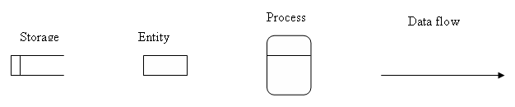

### 3.5 Weakness of the Current System

* Physical processing of childs details and queries is liable to human errors and mistakes.
* Inefficient preparation of reports that may be required by management.
* A lot of money is spent on stationary and paperwork.
* In the event that there is need to address queries response time is slow since there is no way to quickly enquire results from a query form.
* Loss of information due to mishandling of files, carelessness in filing and omission when filling some information.
* The work is tiresome and monotonous, to file papers and go through all files when some information is needed since there are many files.
* No audit trail is evident and records are not always up to date.

## *3.6 Evaluation of Alternatives*

Having produced the user requirements, the analyst noted that there is need for a new system to replace the current one. A decision had to be made as to how the current system will be replaced. The analyst came up with the following (3) alternatives for the current system. These are **outsourcing**, **improvement** and **development**.

* **Outsourcing**

This entails the process of subcontracting the system development process to an external organization. In actual fact the system is developed with close involvement of the users who shall be operating the system. After completion of development process, the software developer does system implementation; users are trained on how to use the system. This task is complete when all user requirements initially specified and those refined before its completion. The problem is that the system is rigid. It is difficult to make changes and if errors occur it takes time to solve since the developers have the right and have to be consulted. It is expensive in the long run as upgrading will involve outside developers from outside the organization.

**Advantages of outsourcing**

* It is faster than all other development strategies

**Disadvantages of outsourcing**

* Expensive since an outside contractor is employed, every time the software needs maintenance the contractor is consulted which is expensive.
* The software solution might not meet the required specification of what the user exactly wants.
* **Improvement**

The current manual system involves filing of records. In the filing system labeling files in alphabetical order files containing records for all activities at the hospital can improve the system querying. However, because of high need of security, the current manual system cannot be improved. In hand to this, the system is lagging behind the present day technology. Thus, new technological features cannot be incorporated into the current manual system.

Improvement is costly in the training of users, additional employees are required and it needs to be upgraded more often to keep up with the current environment it operates which is costly.

**Advantages of improving the current system**

* It is easy and simple to use a manual system for employees as they are used to the manual processes.
* Development time and costs are reduced if the manual system is simply upgraded.

**Disadvantages of improving the current system**

* A manual system is prone to human error hence continuation of the current problems.
* Operating costs are inflated due to hiring specialised personnel (systems analyst) and it could prove to be the most inefficient and expensive solution in the long run as the company would be vulnerable to fraudulent activities, denial or delay of crucial business transactions.
* As a solution it would not comply with the organizational policy of empowering business units through IT.
* A manual system results in the underutilization of the available computer and network infrastructure as well as the available IT human resources.
* **In house Development**

Alternatively programming languages could be used to develop an in-house application package. The languages include Visual Basic, C++, and Borland Pascal., 4thgeneration techniques have made it possible for user to implement Windows icon mice and pull down menus and what you see is what you get. Facilities such as error messages are possible as well. Some of the advantages of using programming language are that file handling is controlled by user of the system, the user interface of the system is up to the user, the package would be made with main focus on the application area and it can be linked up to database and other programs as Macros perform special operations. Some of the setbacks are that programming is generally considered difficult and that development of the system will take time. According to the analyst’s cost benefit analysis, it is feasible to develop an In-house package using Visual Basic 6.0 language. The development personnel is available, thus system maintenance tasks would need not to be done by external personnel.

**Advantages of in house development**

By adopting this approach to develop the computerized system, the following merits will be realized:

* System Ownership – System users assume complete ownership of system as system specifications are based on user requirements during system development.
* Employee Development - Although in-house development is challenging, Marondera Registra will continue to build its employee skill base through in-house development and training of staff.
* Technical expertise **–** Marondera Registrar General system developer has some knowledge in development using Microsoft Visual Studio 6.0 (Visual Basic 6.0) proposed development tool as well as database programming and administration using Microsoft Access 2003. There is expected extensive support from other IT staff members
* In-house development significantly reduces development costs.
* In-house development increases the likelihood of coming up with a system that meets all user requirements.
* Maintenance will be simple since the system will be a product of the organization’s IT. Department

**Disadvantages of in house development**

* Takes more time than buying a software package

**Selecting Alternatives**

The above table shows that **Development** is the best alternative because it is fulfilling almost all the requirements, which the user wants in the new system. The advantages associated with this alternative solution can address the weaknesses of the existing system and help the Marondera Registra to achieve its goals.

The computerized system might solve the problems of the current system and give a bright picture of the operations of the hospital. The system should be developed using Microsoft Access for data storage and coded in Visual Basic 6.0.

### 3.7 Requirements Analysis

Requirements engineering is the process of finding out, analyzing, documenting, and checking the requirements of the system. It also describes services what the system has to provide, constrains being taken into account. Also there is description of quantitative and qualitative features of the solution from the perspective of the user.

**3.7.1 Functional Requirements**

The proposed system should be able to function in the following way:-

* **Security.**

The users suggested the need for a secure system. The system should allow creation of user Groups and Users. Each user should be assigned his/her login name and password by the Administrator. Without these credentials, a user cannot be able to use the system. Each user should be assigned to User groups and Permissions and Access rights are granted to the User Groups.

**Data entry**

The system should allow the following with respect to data entry:

* Capturing dates on which the transaction was made.
* Validate data entry.

Verify details (e.g. childs’ details).

* **Validation and Verification:** The system must have facilities for integrity checks and to allow clients to verify data before it is captured into the system.

The Functional Requirements can be represented in Use Case Diagrams below, as Use Case defines a goal-oriented set of interactions between external actors and the system under consideration. That is, use cases capture who (actors) does what (interactions) with the system, for what purpose (goal). A complete set of use cases specifies all the different ways to use the system, and thus defines all behavior required of the system--without dealing with the internal structure of the system.

**Key to diagram**

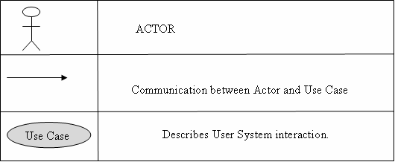

**Fig 3.3: Use Case Diagram**

**Audit trail**

The system should provide extensive audit trails and reporting on changes to filed critical to the system. The system should store the user who made the changes, the date the changes were made and the types of operation (i.e. delete, add, modify).

**3.7.2 Non-functional Requirements of the new system**

* **User friendly interface**

The system should allow quick and flexible means of entering information for processing and graphic user interface (GUI) based on Windows architecture should be employed. The system must be easy to use so as to reduce the cost for errors that might be produced.

**3.7.3 Constraints**

* **Response time**

This is the elapsed time between submitting a transaction for execution and receiving a response.

* **Transaction throughput**

The average numbers of transactions that can be processed per minute, which must be measured under pick times.

* **Space utilization**

The amount of storage space used by the database files and their access path structures.

## *3.8 Conclusion*

After analysis of the alternative, the development of a new system was thus chosen as the best option for the replacement of the current system.

# CHAPTER 4: DESIGN PHASE

**4.1 Introduction**

Having successfully gone through the existing system, and fully understood how it operates it was seen necessary to get into the design phase of the proposed system. This entails outlining how the proposed system is going to be developed, configured and deployed. Generally, the design phase gives an outline of the System Design, Physical Design, System Architecture, Database Design, Interface Design and Program Design

The system will be designed along the following keywords and guidelines:

**4.2 System Design**

This looks at how the system works. This phase should produce an effective, reliable and maintainable system possessing the following characteristics

The following are features of a well-designed system:

* Effectiveness;
* Reliability;
* Maintainability.

All these features should be present in the proposed Marondera Registra system.

### Effectiveness

A well-designed system should be easy to work with and result in some benefit or reduction of costs. Whoever is going to use the system should be involved in designing the system so that they can operate it in the most efficient and effective way. The users should be able to find their way round the system comfortably.

### Reliability

A well-designed system should be reliable in that it would counter problems encountered in the existing manual system.

* **Maintainability**

The system must be easy to maintain, in cases were developments need to made or new features need to added-on to the system. The need for developments or added on features may arise as a result of changes in the external information technology environment or changing business needs. System must flexibly adapt to changes, making it easy for modifications and updates.

**4.2.1 Description of the proposed system**

Guided by the limitations, general environment and exceptions that are prevailing in this scenario, it was only suiting that computer-based system is used to solve the problems being faced in the current manual system. The current manual system has been described and completely analysed before hand.

**4.2.1.1 Functionalities**

The proposed system is expected to support the following functionalities:

* **Childs module**

This is for manipulating child’s records in the database, it also contains options for editing child details, delete child if child has passed away or no longer taking treatment with the hospital, update child treatment records and search for child details.

* **Drugs module**

The drugs module will be used to register new drugs which are new to the system, update inventory for the drug after orders have been made, delete drug record and search for drugs to view drugs records if there is any need.

* **Administrator module**

This module enables the administrator to navigate through the whole system. It contains functionalities like the production of system reports, back up of the system adding, updating and deleting of users.

* **Reports Module**

All the reports will be shown in this module according to the specification of the administrator depending on which type of reports he wants.

* **Backup module**

The database backup will be done in this module.

**4.2.1 Context diagram of the existing system**

The dataflow diagram shows how data will flow in the existing system.

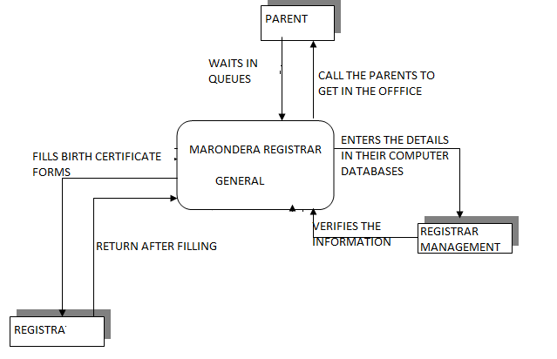

**Figure 4.1 Context diagram of the proposed system**

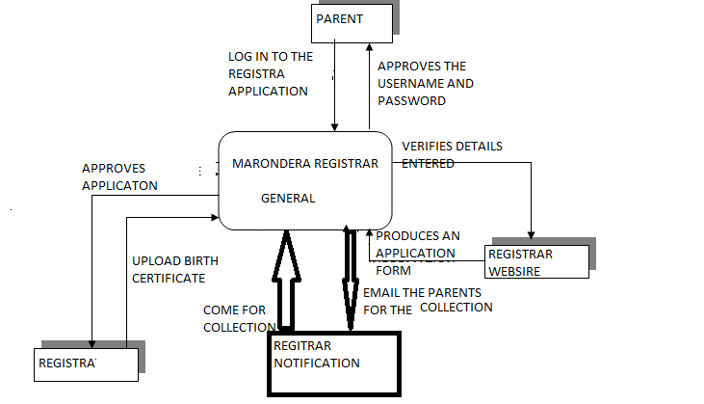

**Data flow diagram of the proposed system.**

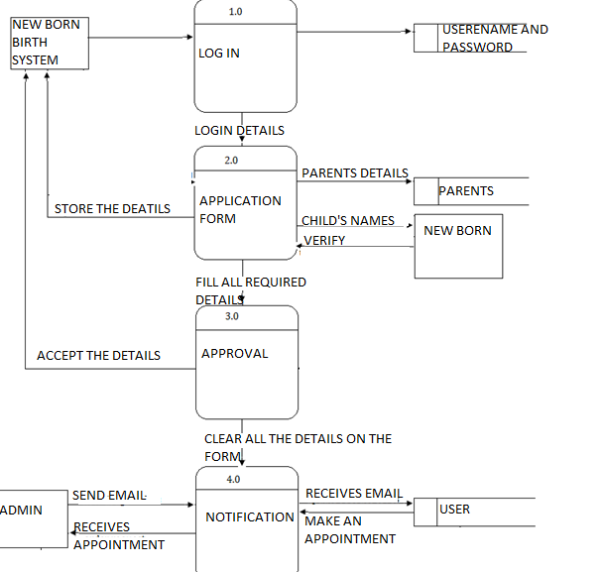

**Figure 4.2 Dataflow diagram of the proposed system**

**4.3 Architectural Design**

Architecture design looks at the hardware setup and configurations of the proposed system and shows where the major components of the system will be connected and how the several machines and people that make up the system will be connected. This provides a description of the technical platform (environment) on which the new system will run. It describes the logical and physical layout of the system including the specifications of hardware, software, data, procedures, and the people to be involved.

The diagram below shows the architectural design of the proposed system.

**USER SIDE.**

**SERVER SIDE.**

**SERVER.**

**DATABSE.**

Data capturing and storage.

Modification to the stored records.

**Fig 4.3: Architectural Design**

For a user to be able to access the contents of the server, he has to pass through the barrier between the Client side and the Server side by providing the correct authorization details such as username and password. Once the details are verified and validated as correct the user then can use different functions depending on the task at hand for example searching for the performance trends from the database. A firewall will also be put in place as a security measure.

Architectural deign describes the technical environment including hardware, software, procedures and user. The objective is to minimize bottlenecks in the system caused by hardware, software and architectural factors. The system should run on a reliable hardware platform and measures should be taken to reduce vulnerability of the system to hardware/software related threats. The system should be backed up regularly in case the system is corrupted or lost. The developer also considered measures that should also be put in place to reduce the negative effects of power cuts on the system and this involved installation of a UPS system.

## *4.3.1* *Hardware Requirements*

* + Pentium III (300Mhz)
  + At least 500 MB of Ram
  + 100 gigabytes hard drive
  + A 14’’nch Color Monitor
  + Power cables
  + UPS
  + Hp laser jet printer

## *Software Requirements*

* Microsoft® Visual Basic 6.0
* Microsoft® Access 2000 (format)
* Eset node 32 (Business edition) antivirus
* Microsoft® Office 2003

**4.4 Physical Design**

The system database is going to be accessed via the administrator account. Other departments will have their machines configured for their respective modules and they would log on with their access rights that permit them into the system. The administrator will be able to use the server when performing administrator duties. The database on the will be backed up regularly using backup disks. The setup of the machines on the network is illustrated below:

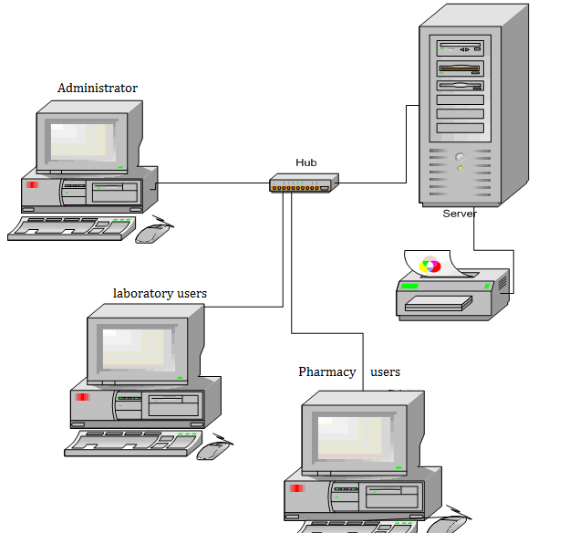

**Fig 4.4 Network setup of the system.**

**4.5 Database Design**

Data will be entered and stored via the Visual Basic forms. The developer has adopted a database approach because of the following benefits over file-based system:

* The data is held in such a way that changes to the structure of the database do not affect any of the programs that access the data. This is direct contrast to the non-database approach, where minor change in a file structure may mean a considerable programming effort.
* Since each data item is held only once, there is no danger of an item being updated on one system and not on another.
* In a non-database system, the same information may be held on several files, which may not only waste space but makes updating more time-consuming.
* NB in databases, system redundancy is not always completely eliminated, but minimized.
* With database systems, users have access to information that was previously held in separate files in other departments, and sometimes on incompatible systems.

user

**4.6 Interface Design**

### Introduction

This is the design of the interface of the new proposed system to be used. It outlines the design of the menus and forms for data input into the system. It also gives an outline of the structure of the input and output of the system.

The first thing users will look at before they even test to see if the system meets their requirements is the interface. The interface design is therefore paramount for the acceptance of the system.

### Functional Structure Design

The designer has decided to develop a system, which will be like most windows based applications in appearance. This was chosen because the system has to be as user friendly as possible so as to meet one of the objectives of the new system.

The new system will have a main platform from which control of the whole system will be possible. All processes should be done within that platform. Navigation will be possible using a menu bar on top of the application’s main platform, just like other windows based applications. The menu should be designed so as to allow users to use the keyboard or mouse for navigation.

Before one is allowed into the main menu, one has to enter into the system by entering a username and password.

The chart below will show the structure of the interface design that will lead to the Main Menu design.

Log in

Main Menu

System task

Application form

Notification

Administrator

Reports

Database

**Fig 4.6 Main menu design**

## *4.6 Interface design*

This is a process of defining how the system will interact with external entities. In this project we are focusing on the design of user interface, security design, the nature of main menu and menu designs, tool bar, inputs and outputs in the system, ways of accepting data and producing of information. Navigation mechanism is the way in which the user gives instructions to the system and tells it what to do. The user will use command buttons to navigate the information that he/she needs to know.

Such command buttons include, the add record, delete record, save record, post record, print record and report. These buttons will appear on all the forms and a user can use these command buttons to navigate information in the database. Other functions such as will depend on the form and will directly pick required needs from the tables in the database. The end users will at one time neither interface with the tables where data is not stored nor will he/she interface with the queries. All database interactions will be through interactive forms.

### 4.6.1 Security Design

The system has to be secure from external users this reduces the risk of modification of information by unauthorized users. Information can be made secure by using software controls. In our system the database administrator has implemented software controls and these includes the use of passwords whereby level of permissions and roles are set defining whether the user is a super user with super rights or just minimum rights.

The second level is there to further protect the system happens in case such a situation occurs. The system provides a log-in feature where password entered is verified. The login feature will be designed as follows:

### System Login Form

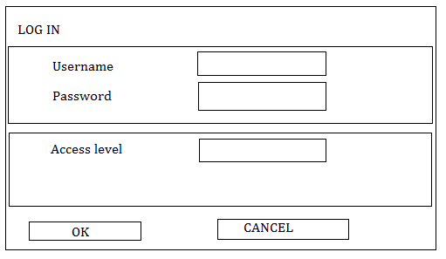

Text box for data input

Command buttons for dialog

**Figure 4.7 System login form**

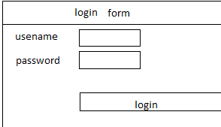

The screen above will be used, as a security measure to the system so that only authorized users will be granted permission into the system. User must enter their user name and password and access level to enter the system.

### Main Menu Form

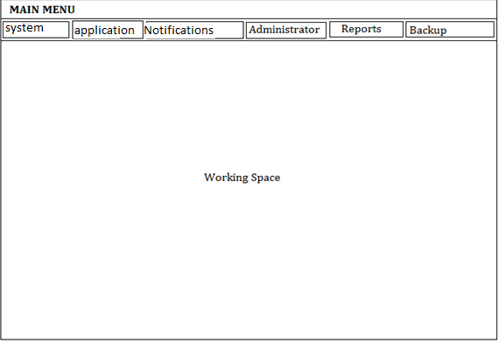

All the systems operations will be done in the platform **‘Working Space’** and changing between forms will be through the use of the menus provided. The main menu form will have drop down menu on which users will select their forms using either the mouse or the keyboard.

### 4.6.3 Input Design

Input design is the design of input that is processed in the system and processed to produce output and the input is usually the forms. Sample forms for our system were designed and these were child capture form. The new proposed system will contain input forms that will allow users to enter all the necessary details. All the input forms will have a close button for closing the particular form so as to return to the main menu of the system. Searching and calculation processes will be performed by the system as part of its computerization process.

The following rules apply on input forms:

* + Data will be validated on entry into the system.
  + Once data is captured through the Input Forms, it is stored in the database.

Below is a list of input forms and how they work.

* Registration capturing Form

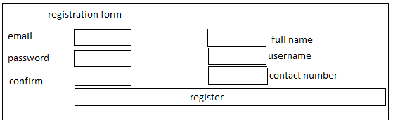

**Figure 4.9 Child details capturing form**

The child details capturing form is used to capture details of a child who is a new born to the family.

* Online birth registration form

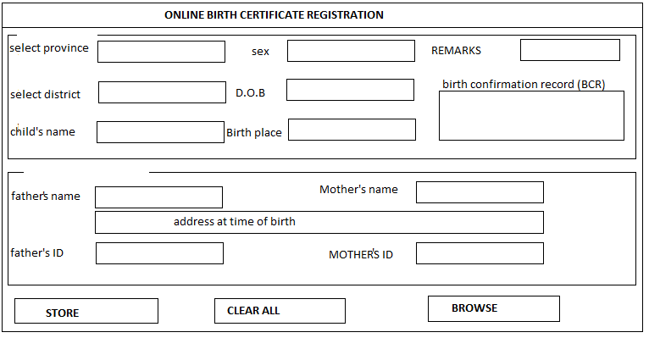

**Figure 4.10 Registration form**

After the initial child details have been captured the record is now updated using the website.

* Delete child form

**Figure 4.11 Delete child form**

The delete child form is used to delete all the child details of the child in the system after may be the new record is being created or the child has passed away.

* View childs form

**Figure 4.12 View childs form**

The view child form is used to view all the childs registered with the system.

* Add user form

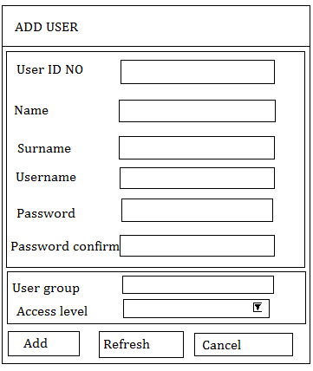

**Figure 4.13 add user form**

The add user form is used to register a new user with the system. It is done by the administrator.

* Change user password form

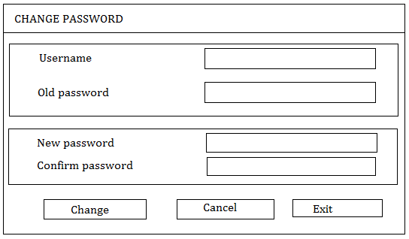

**Figure 4.14 Change user password form**

The change user password form is used to change the password of system users. This is done as a security measure to change user passwords at random times.

* Delete user form

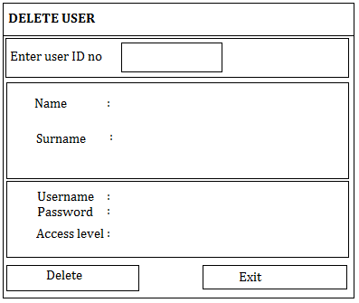

**Figure 4.14 Delete user form**

The delete user form used to delete users who have been operating the system because of either he is no longer employed with the organization or the access level has changed.

* View users form

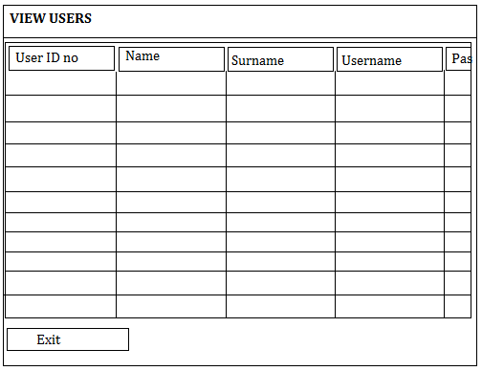

**Figure 4.16 View users form**

The view users’ form is used to view all users currently using the system and their current state.

**Figure 4.21 Backup form**

This form is used to perform backup to the system database. The database can be saved to either another drive I the system or to an external media. Only the administrator performs backup.

**Output design**

This segment outlines how the data in the database is going to be viewed, that is it focuses on typical report designs for the proposed system. The output methods used include forms for displaying processed data and report for printing. The output interface is designed in a way that is easy to use.

The reports will be created using Microsoft visual basic report maker.

The following are the reports which will be developed in the system.

* + Child treatment reports

### 4.6.5 Selection and design of the method of data capture

Having analysed the types and forms of data that is required in the system, it becomes quite clear that the most suiting method of data capture would be:

* + Keyboard entry

I discovered that a lot of people could read and write implying that having something that imitates actual traditional writing would be the best option and that led me to bring out the keyboard. It has the following characteristics:

|  |  |
| --- | --- |
| *Advantages* | *Disadvantages* |
| 1. Duplication of data entry could be reduced by the use of cut and paste routines. | Very difficult and time consuming in use for someone who is not so conversant with it. |
| 2. Familiarity is already there since it is laid out in the same structure as a keyboard. | The speed of the operation of the keyboard is dependent on the speed of the operator. |
| Cheap to replace and install. | Science has proven that long hours using the keyboard will eventually lead to illness. |

* + Mouse

The mouse is a very useful tool in the input of data to the extent that some have started saying, “Word of Mouse is faster than word of mouth” – just to show how much things have changed in the world of information technology. Using both the mouse and the keyboard would produce a very good communication channel for the user to communicate to or with the computer. Below is a list of advantages and disadvantages for mouse.

|  |  |
| --- | --- |
| Advantages | Disadvantages |
| 1. Easy to use: “WYSIYG” – What You See Is What You Get. | It is limited to only those areas where it is configured to work otherwise it will not be applicable. |
| 2. Cheap to replace and install. | Could lead to over dependency on it which might make the user lesser of an efficient user of the system. |

#### Validation checks to be carried out

* + Length (e.g. of name)
  + The number of characters entered in the name field should not exceed those set in the database. Validation for name should also be in such a way that the field only accepts numeric letters of the alphabet.
  + Type (e.g. of number/text)
  + The type of text is very important because it enables us to check if the system has been validated. Usually only that text that has been stated in the database should be entered.
  + Format (e.g. date/time)

The data/time field should be validated such that the system can only accept dates within the range and cannot accept the dates out of range. By so doing users are unable to manipulate data or and information for their use. Basic date format should be set for example mm/dd/yy. A wrong date should always give an error message.

**4.7 Conclusion**

The design of various components of the proposed system done so far can allow the coding **phase** to begin.

# CHAPTER 5: IMPLEMENTATION PHASE

## *5.0 Introduction*

The implementation stage will involve the installation of software, testing, maintenance and training of users by the developer. The system is then tested to discover any errors so that corrections can be made before it can be installed. Testing process is repeated several times until all identified errors have been corrected.

The system will run parallel to the existing system for two weeks so as not to loose any information should the system fail for any reason. One disadvantage of this method of implementation is that there is duplication of effort imposed upon the user department as it is likely that the same persons have to run both the system during the periods of parallel running.

## *5.1* PROGRAM CODE SEGMENTS

Code for login, making changes, adding birth certificate

<?php

include "header.php";

?>

<div id="main_content">

<div id="left_content" style="width: 400px">

<h2>Login</h2>

<p>

</p>

<form action="login.php" method="post" name="sub" id="sub" enctype="multipart/form-data">

<table border="0" align="center">

<tr><td> Email :-</td><td>:&nbsp;</td><td><input required type="text" name="user" /></td></tr><br>

<tr><td> Password :-</td><td>:&nbsp;</td><td><input required type="password" name="pass" /></td></tr>

<tr><td>&nbsp;&nbsp;&nbsp;&nbsp;&nbsp;&nbsp;&nbsp;&nbsp;<input type="submit" name="sub" value="Login" /></td><td></td><td>&nbsp;&nbsp;&nbsp;&nbsp;&nbsp;&nbsp;&nbsp;</td></tr>

</table>

</form>

</div><!--end of left content-->

<div id="right_content" style="width: 400px">

<h2>Hints To Register</h2>

<?php

include "how.php";

?>

<div class="products_box">

</div>

</div>

<?php

include "infor.php";

?>

</div><!--end of main content-->

<?php

include "footer.php";

?>

<?php

// Inialize session

session_start();

// Include database connection settings

include('rb.php');

$db=R::setup('mysql:host=localhost;dbname=portal', 'root', '');

$_SESSION['last_login_timestamp'] = time();

$username = $_POST['user'];

$password =md5($_POST['pass']);

$activity = "Log in";

$Time = time();

/*

---------------------------- ---------------------------------------------*/

$init = R::findOne('users', 'email = ? AND password = ?', [$username, $password]);

if ($init == null) {

// $message = "invalid details";

print ("<script>window.alert('invalid details')</script>");

print ("<script>window.location.assign('index.php')</script>");

} else {

@session_start();

$_SESSION['email'] = $_POST['user'];

$_SESSION['name'] = $init->name;

$_SESSION['user'] = $init->username;

$_SESSION['grade'] = $init->grade;

$_SESSION['place'] = $init->place;

$_SESSION['role'] = $init->grade;

$_SESSION['id'] = $init->id;

$act = $activity;

$Time = time();

echo '<div class="alert alert-success" role="alert" style="background-color:transparent">...<h2 style="color:white">

<img src="images/success.png"/>

!login successfull </h2></div>';

if($_SESSION['role']=="admin"){

echo ' <h2 align="center">

<meta content="2;admin/dashboard.php" http-equiv="refresh" />

</h2> ';

}else{

echo ' <h2 align="center">

<meta content="2;bentry.php" http-equiv="refresh" />

</h2> ';

}

// print ("<script>window.location.assign('index.php')</script");

}

?>

<?php

include'conf.php';

// Inialize session

session_start();

// Check, if username session is NOT set then this page will jump to login page

if (!isset($_SESSION['user'])) {

header('Location: timeout.php');

}

$user_id=$_SESSION['id'];

$invp=$_SESSION['user'];

$inv="select * from users where username='$invp'";

$ansinv=mysqli_query($con,$inv);

while($row=mysqli_fetch_array($ansinv))

{

$invoicepre = $row['ccode'];

}

$ino="select id from birthreg";

$ansin=mysqli_query($con,$ino);

while($row=mysqli_fetch_array($ansin))

{

$no = $row['id'];

}

@$sql2 ="SELECT id FROM birthreg WHERE id > '$id' ORDER by id DESC LIMIT 1";

$resultn = mysqli_query($con,$sql2);

$nextrows = mysqli_num_rows($resultn);

while ($nextrow = mysqli_fetch_array($resultn)) {

$next=$nextrow['id']+1;

}

$d=date('Y');

$m=date('M');

$no=$ino;

$a=$invoicepre .'/'.$d.'/'.$m.'/'.$next;

$status=false;

$filetmp= $_FILES['image']['tmp_name'];

$filename = $_FILES['image']['name'];

$filetype = $_FILES['image']['tmp_name'];

$filepath= "documents/bcr/".$filename;

move_uploaded_file( $filetmp,$filepath);

$date= date('d-M-Y');

$sql="INSERT INTO birthreg (Registerno, districit, zone, name, sex, dob, pob, father, mother, p_address, a_t_birth, remark,bcr,users_id,status,mid,fid, dor)

VALUES('$a','$_POST[dist]','$_POST[zone]','$_POST[chname]','$_POST[sex]','$_POST[bday]','$_POST[placebirth]','$_POST[father]','$_POST[mother]','$_POST[paddress]','$_POST[aaddress]','$_POST[remarks]','$filename','$user_id','$status','$_POST[mid]','$_POST[fid]','$date')";

echo @$id;

if (!mysqli_query($con,$sql))

{

die('Error: ' . mysqli_error());

}

echo"<script language='javascript'>

alert(' Birth Registration Sucessfully submitted.......! ' )

window.location = 'bentry.php';

</script>";

//echo $a;

//

//echo "<b>Invoice Created Sucessfully........! </b><br><br>";?>

<?php //echo"<a href='makebill.php'>Back</a>";

mysqli_close($con)

?>

</center>

## *5.2 Coding*

This applies to the actual coding of the modules and the database. The code is likely to be more that 50 pages as this code will be for each text box, label or command button. Code will also be put to activate certain queries. The code being used is the Visual Basic Version 6.0 with Microsoft Access Database. See Appendix for Sample Code

A pseudo code was first developed to represent the general functionality of the system. It briefly describes how a user can navigate in the system starting from log in into the different modules found in the system.

**Pseudocode**

* **Login**

Enter username, password and access level

If correct then

Go to system main menu

Else

Try again

End if

* **Creating a new record**

Validate all the information

If invalid input is entered

Report error

Else

Using the established connection, save details

* **Updating data in the database**

Get the key field

Check if record does exist

If not then

Report error

Else

Validate all the information

If some of the input is invalid

Report error

Else

Using the established connection, save record

* **Searching for a record**

Get the record ID

Using the established connection, retrieve data

If data has not been found then

Report error

Else

Display data

Allow the user to edit

End

* **Deleting records**

Get the record ID

Using the established connection, display record

If record not found then

Report error

Else

Display data

Allow user to delete data

End

* **Viewing records in the database**

Get the records from database

Using the established connection, display all records

End

* Preparing reports from database

Get data from database

Use the specified query to prepare the report

End

## *5.3 Testing*

Intensive testing was done in order to make sure that all components of the database were functioning as required. This involves numerous methods of testing so that the system could meet the user specifications. The diagram below shows the procedure in testing.

Unit Testing.

Module Testing.

Sub-System Testing.

System Testing.

Acceptance Testing.

### Figure 5.1 System Testing Procedures

### 5.3.1 Unit Testing

This test will focus on one unit of the program, a module or function, and the objective is to check whether each unit performs its task as specified. Unit tests are done in two scenarios:

#### Black Box Tests

This is concerned with the inputs and outputs of a unit only. In our case we tested the functionality of querying the database by selecting records that we wanted to view and we filtered by name such that only records of a certain child will be displayed. If all is selected as an option the all invoices in the database will be displayed.

#### 5.3.1.2 White Box Tests

This focuses on the inner working detail of a unit and it will help find errors not immediately identifiable by treating a unit as a black box.

### 5.3.2 Module Testing

This method of testing combines dependent components and testes them together. A collection of procedures and functions were tested together. A single component can be tested without other system modules. Usually module testing is done using the set objectives; we used objectives to measure the reliability and functionality of our modules. In this type of testing modules such as the childs’ records were tested for their dependency on billing modules. The idea behind was to check if the system was updating the accounts before the child left. Also to find out if the program would make subtractions in database once the child pay his or her bill. The system was capable of producing the systems objectives and therefore concluded to be working properly.

### 5.1.3 Subsystem Testing

This is also called link testing. It tests a collection of modules, which have been integrated into subsystems. It ensures job streams are correct. There is detection of interface mismatches and rigorous exercises of the interface between programs. The modules, which are linked together were tested, in this case the childs’ module was tested. When a child visits they are to be entered into database for updates. This was done and the system was a success in performing the function.

### 5.3.4 System Testing

This involved testing of the entire information system and it includes all processing situations. The sub modules tested above are integrated to make a system. These were tested to find if there were any errors, which would hinder the performance of the system as a whole. Live data was used and there was verification that the system worked correctly.

### 5.3.5 Acceptance Testing

This involves testing using end users of the system and some other programmers rather than the project programmer so as to reduce bias. A few friends validated the system to check the following characteristics:

* System security
* Reliability
* Accuracy
* Processing speed

Also the user acceptance testing is done to determine if the system is complete, whether it meets business needs and acceptable to the user. It is composed of alpha and beta testing.

#### 5.3.5.1 Alpha testing

The system will be delivered to the organization that will use it and report any problems posed by the system and detect errors. If errors are present they are corrected and further release of system is carried out until it meets al functional requirements.

In our case the Acceptance testing was done in the presence of the Provincial Registra and end users of Marondera Registra. The system was thoroughly reviewed and function areas that were not working properly were corrected.

#### 5.3.5.2 Beta testing

The system is tested using real data supplied by the Administrative users and the administrator who would be using the system will also input their data. Errors and omissions in system requirements can be discovered and this process continues until the organisation accepts that the delivered system is ready for delivery.

### 5.3.2 Test strategies

We used a number of test strategies in trying to ensure the correct functionality of programs and the system as a whole. We managed to identify syntax errors and logic errors through the use of code reviews and structured walkthroughs. Some of the test strategies used is below.

#### 5.3.3.1 Validation

This is whereby we evaluated the system to check whether we had built the right system. Various objectives of the system were looked upon to see if they had been achieved. For example if we enter the numeric text in the field for alpha text then an error will appear for example upon pressing a key which is not a letter in the surname text box an error message will appear as shown by the example below, also if you enter alpha text in numeric field such as phone number an error will appear. We concluded that the system is a true representation of the system development project. This process was to ensure that the system would be delivered without errors.

**Figure 5.2 validation screen shot**

#### 5.3.3.2 Verification

This was also intensively done. This is whereby we looked at the system to see whether we had the developed the correct system. This means that the system was checked to see if it was meeting the customer specifications and requirements. The system might be excellent (running and fully functional) but not meeting the user requirements. Verification was also done intensively. We managed to check and analyze system representation using static techniques to check on requirements documents, design diagrams, program source code and inspections. We tested the system with some data and compared the results with already known results. We used the white box method of verification where the tests were conducted to ensure that the internal operation of the system performed according to specifications and all the internal components had been adequately exercised.

### 5.3.3 System Security Testing

Security is implemented through the use of physical and software measures. These include passwords, security user levels, burglar bars, tags and security guards. System security aims at protecting the system from vandalism, intentional negative incidences like fraud, theft and accidents. The objective is to avoid the occurrence of damage to the system or minimize the effects of an attack. These accidents can occur to hardware, software, data and the network.

We looked at how the risks may occur and then decided on ways which we can control and protect these risks. A threat to the system is any potential adverse occurrence that can do harm to the application or its data such as a computer virus or unexpected natural disaster or disruption. Disruptions occur when there is power failure or user mistakes causing the network to cut or cease functioning. Some disruptions may also be caused by destruction of data for example a virus may destroy files and other destruction may be catastrophic such as natural.

An example of one of the security measures in the system is the use of password, username and access level. If the user or any unauthorized user tries to login and if any of the text fields is wrong. The system will display an error message and prompt the user to log on again as illustrated by the example below.

**Figure 5.3 system security screen shot**

**5.3.3.6 Control of destruction, disruption and disaster.**

* Viruses can be prevented through the use of anti-virus packages such as esset node anti-virus and Microsoft security essentials Software which should be updated regularly. This checks disks and files to see if there are any viruses, which should always be updated.
* The system shall be in the server room, which shall be locked to be only accessed by the IT personnel (database administrator) with tags and their secret numbers that can swipe in after punching the number.
* Disasters must be controlled through having the application and its data stored in a separate location so that it can be retrieved on emergencies.
* Hardware can be insured.
* Having backup for data. Backup shall be done through the use of the Transmission tape (20-40 GB) in case the system crushes. Daily backup is done and disks can be run for particular days on which a system would have crushed. There are also weekly and monthly backups in order to safeguard un eventualities following a system’s crush. In addition backup shall also be done through the use of CDs on a weekly basis. The backup CDs together with the floppy disks are going to be kept in a strong room that is locked all the time and can only be accessed by the IT personnel. This strong room is located some distance away from the IT section and server room in case some disaster occurs in the IT section.
* Update method for Network interruptions.
* Uninterrupted Power Supply devices for any loss of power supply.
* There must also be a good restart function, which makes use of program status indicators so as to try and control errors caused by interruptions human made destruction.

#### 5.3.3.7 Software Security

The system uses passwords, security levels and contact numbers for tracking of transactions. Each user is assigned a password by the database administrator who has super rights. The modules and granules to view depend on the level of permissions assigned.

## *5.4 Installation*

Installation is when the developed system is being installed. Users are changing from using the old system to using the new system. In this phase the required software is installed on the appropriate hardware converting from the as-is system to the to-be system. Users are moved from using the old system to using the new system though in most cases the two systems (new and old system) may run parallel to each other.

A number of activities such as training, file conversion, system changeover methodologies such as direct changeover, parallel running and pilot operation are carried out during this stage.

### 5.4.1 User Training

We developed a training plan for users, which included all the entities in the running of the Integrated Systems. The training was mainly conducted to familiarize end users with the new system. We conducted a training that encompassed the management as well. Management should be also familiar with the system so that they are able to evaluate reports that are given to them for management evaluation purposes.

Training

g is done so that users are able to use the system. Training is not only for users, management also needs to be trained to be able to know the operations of the system in right time and to the right people. The system developers conduct the training until users are acquainted with this new system they would use.

We conducted training in groups with separate programs for distinct groups. The training was well structured as each module was demonstrated before proceeding to the next module. Questions were entertained from the trainees and test questions were also given l so that users become free to ask any queries they would not understand. We concluded our training by conducting a full-scale simulation for the staff for them to gain experience and confidence. At the end of the training session users were given forms with questions to fill so that we could evaluate the impact of the training.

### 5.4.2 Operation Environment

This is tested before the file conversion. Access was limited to users and we used live actual data and managed to verify all changes and we then obtained user approval. We examined all the system components that affect system performance such as:

* Hardware
* Software configuration
* Operating system programs
* Utilities
* Network resources

We found these to be functioning efficiently before we loaded and after we loading programs

### 5.4.3. File conversion

After the users have verified the results of the testing process the files are the transferred to the new system. Programs need to be designed which would do this conversion process. As the users would be using the system during working hours, the files will be in use, thus the conversion will be done during the weekends or outside working hours.

File conversion follows soon after operational environment has been established and training has been conducted. Under the normal schedule we had set, it took us three weeks to transfer manual data into the new system.

### 5.4.4 System Changeover

It is the technical process by which the new system replaces the old system. There are a number of approaches to system changeover namely:

#### 5.4.4.1 Direct Changeover

The old system ceases to function and is replaced immediately by the new system.

##### *Advantages of direct change over*

* Efficient method in so far as it minimizes duplication of work
* Less costs as only one system would be in operation

##### *Disadvantages of direct change over*

* New system may not be entirely correct
* It is difficult to make the system operational when some errors are identified after changeover and need correction
* Requires careful planning, testing and attention to operational detail

#### 5.4.4.2 Parallel Running

The new and old systems run in parallel for a short period then the old ceases operation after sometime.

##### *Advantages of parallel running*

* Low risk as a results can be verified and a back up option exists

##### *Disadvantages of parallel running*

* Relatively high costs as both systems are in operation at the same time for some time
* Method cannot be used for systems which are not similar

#### 5.4.4.3 Pilot Operation

The old and new systems operate at the same time but at a pilot site. The rest part of the organization continues using the old system.

##### *Advantages of pilot operation*

* Moderate costs as only a chosen site would be running two systems at once
* A moderate risk of failure as the new system is only installed at the pilot site.

The developed system is placed in actual site and tested before actual use to check if the system operates according to the set aims and objectives. System processes are checked to see if they perform according to the user requirements.

#### 5.4.4.4 Phased changeover

With this, the system is implemented in stages or modules across the organization. Phased changeover gives part of the system to the organization and cost is relatively moderate as the system is implemented in stages rather than all at once. Risk is also very moderate because the risk associated is limited to the module being implemented.

### 5.4.5 Post Implementation Evaluation or recommendations

We discovered that the new system was accurate and timeliness in the producing of output. It also yielded also a high level of user satisfaction. Generally, the new system was reliable and maintainable. It had also better system control and security. The users responded well to the training and they deduced that the new system was user friendly and had an effective database that added business value scheme.

### 5.4.6 Justification

For installation we chose the Parallel Running installation method because we found that though it may be relatively strenuous it was the most ideal method because of the following reasons:

* Risk is relatively low since back up (existing system) exists.
* Data is input into both systems and results obtained from both systems can be compared and verified.
* The users are subjected to gradual change that they can easily follow thus they are motivated and demoralized by abrupt change.

## *5.5 Maintenance*

Following implementation of the system, there comes a time when there is need for its

Review and this is normally done on monthly basis. It is carried out in this phase.

The system should be maintained to make sure that it still conforms to the specifications. Reviews should be done periodically and if the specifications or environment changes then the system should be upgraded. Maintenance of the system is an ongoing process.

### 5.5.1 Types of maintenance

Maintenance is the process of monitoring, evaluating and modifying the operational information system to make necessary improvements. There are a number of approaches to the maintenance process. The need for maintenance will arise as a result of many different situations occurring throughout the life of the organization and these can include the following:

* If the organization grows, it means a change in the way it operates. The system will therefore require modifications to mirror the changes.
* The users of the system may require additional information that will help perform the system tasks better thus the need to make a few additions to meet such requirements.
* It is possible that initially, the requirements may have been incorrectly specified and when the system is now in operation, corrections will have to be made.

We implemented the system and examined it to see if it is meeting the objectives set out in the original specifications. The system analysts and the project team concluded that the system was meeting the specified objectives but since the environment changes so does the customer requirements.

### 5.5.2 Structured Maintenance

The maintenance process will be carried out as follows:

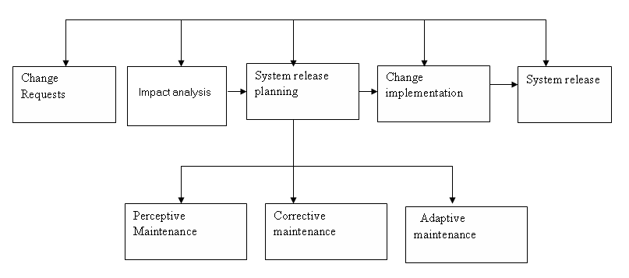

### Figure 5.4 Structured Maintenance

A change request form is submitted and analyzed. If the request is accepted a new release is planned. Release planning involves elements of adaptive, corrective and perfective maintenance.

There are three types of system maintenance are explained:

**5.5.2.1 Corrective maintenance**

This is the maintenance to correct the software faults. Coding errors ere usually relatively cheap to correct, design errors are more expensive as they may involve the rewriting of several program components. Requirements errors are the most expensive to report because of extensive system redesign which may be necessary.

#### 5.5.2.2 Adaptive maintenance

This is the maintenance to adopt the software to a different operating environment. This type of maintenance is required when some aspect of the system’s environment such as hardware, the platform operating system or other support software changes. The application system must be modified to adapt it to cope with these environment changes.

#### 5.5.2.4 Perfective maintenance

This is maintenance to add or modify the system’s functionality. This type of maintenance is necessary when the system requirements change in response to organizational or business change. The scale of the changes required to the software is often much greater than for other types of maintenance.

### 5.5.3 Unstructured Maintenance

**Change**

**request**

**Deliver**

**Repaired**

**System**

**Modify**

**Source**

**code**

**Analyse**

**Source**

**code**

**Figure 5.5 Unstructured maintenance diagram**

At times a system would need a quick repair for the business to run thus the need for this type of maintenance. This is where a request is given by users on an area where a change is requested and the developer analyses the source cone, make changes as per user request and deliver the modified version.

### 5.5.4 Recommendations for maintenance

The management was taught that maintenance is an important process to be given good attention if the system is to live longer while delivering goods.

The system is important because:

1. A system continues to changes and evolves as it is used.
2. The changes were arising from the change and evolve as it is used.
3. The changes were arising from change request due to the problems. Reports from operating groups who identifies the bugs in the system that must be fixed.
4. Changes were arising from users.

## *5.5.6 System Review*

This process ensures the newly implemented system meets the development objectives stated. Errors in the use of the system must be corrected. Periodic reviews are held with the users to audit the system. The purposes of review are as follows:

* To determine if specified objectives have been met and are still being met and if not, why?
* To ensure the users are using the system correctly.
* To check if the system is maintainable and flexible.
* To highlight shortfalls in the development process so that any mistakes can be rectified in future systems.

## *5.5.7 System Back-up Services*

The system should have a back up service in case it is corrupted or destroyed. There should be at least two CDs an external hard drive; one should be kept at the office to cater for corruption of system. The other should be kept away from the business premises in the case of fire destroying resource in the office; a backup would be available. Both CDs should be updated at regular intervals. In our case back up CDs are kept at the Head office and a backup is done on the server everyday and on weekly basis they are brought over on Friday and taken back on a Monday.

**5.5.8 User Manual**

The User Manual is the documentation that will give guidance to the System User on how to use the system. Most of the terminology and interface setup has been adopted from the basic structure and look of Microsoft Windows products. This was done so as to maintain the feel that is associated with using a product that you would be well versed with. Special training to the System Users will be provided to ensure that they become familiar with the new system and its operation as a system.

**See the appendix for the user manual**

## *5.5.10 Recommendations*

From what I have gathered throughout the Life cycle of the project, I recommend that the system be installed and begin to be used with immediate effect. I recommend that before using the system, users should consult the User Manual to familiarize themselves with the system. The users can simply use the system with minimal training because of the temptingly friendly user interface but if they do not know how to exactly go around the system, then the User Manual will be productive in information on how to fully utilize the system.

I would also recommend that the users maintain system security. That is, they should not disclose their password to any unauthorized personnel or let anyone temper around with the system.

I also recommend that the Marondera Registra be consistent with all levels of maintenance because it is an integral process as far as the performance of the system is concerned. Maintenance should be included in the core activities that the work-related-learning department has to cover in a stipulated period of time.

After the completion of all the phases, there was need to appraise the performance of the newly developed system and see whether it managed to meet all Objectives and Functional Requirements that were specified in the Proposal and Analysis phases respectively.

## *5.5.12 Limitations and Constraints*

Whilst all of the objectives were met, there were also some constraints and limitations in achieving these. There were some shortfalls that were encountered in the development of the system and also in the implementation of the objectives. Time was very scarce. I needed to have carried out enough research before developing the system whilst at the same time the user was on my back for results. Therefore, the system was built too quickly to meet the organizational needs disregarding what the market really needs.

Also the head office chose the programming language that was used and this meant that it was to be used. I also needed time to scale and evaluate programming languages because Visual Basic is not a flexible tool in report developing.

## *5.5.13 Performance in relation to Objectives*

The newly developed system works satisfactory so to say. It has managed to meet the following objectives as originally specified:

* Check stock before issuing out an invoice or receipt
* Distinguish between cash payment and credit payment and post to respective accounts or books
* Reduction in the flow of data
* Faster processing and retrieval of data.
* Enhanced security features and logon facilities.
* Run a number of reports as per management such as reorder level reports, interest reports, payment reports and cash book reports.
* Reduction in calculation errors.

## *5.5.14 Suggested Improvements*

After the completion of all the phases, there was need to appraise the performance of the newly development system and see whether the requirements and functional requirements that were specified in chapter one and chapter 3(proposal and analysis) were met.

5.5.15 Suggestions for further Improvements

Given that the system was successfully implemented and that parallel conversion is being used, there is room for further improvements and partial automation to the System. Below is what can be done to enhance the system.

* Since the database will be growing there will be need to move to an advanced Database Management system like Microsoft SQL Server from Microsoft Access 2000.

Although the project took some time to come up due to under budget, it was a successful one. Now it is being implemented and due to the changes in this harsh environment in Zimbabwe changes are continuously made make it adapt to the given environment.

**5.6 Conclusion**

The project was carried out smoothly and it was a success. The implementation was done according to what was really required by the user and the documentation will provide the necessary information if there be need to maintain the system.

## 6.5 INSTALLATION

6.5.1 Steps for Application Software Installation

* The system is installed from the software C.D
* Install system to path. (It is recommended that the system be installed to the program files folder.)
* Verify that the system is installed properly that is all folders are installed.
* Add the system data source.
* Connect data source to the database on the main server housing the system database.

6.5.2 Database Installation

The database management system (DBMS) will use MySQL Server. The DBMS is installed on a central server, which will serve all the other terminals and thus is the Central database

## 6.6 USER TRAINING

**6.6.1 User Manual**

Logging into the system you enter you user name and password and select the group of users you are in.

6.6.1.1 Administrator main

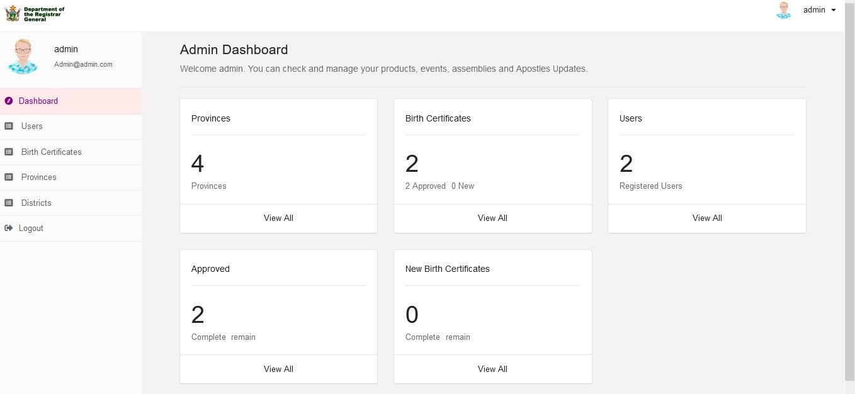

7.6.1.2 user registration

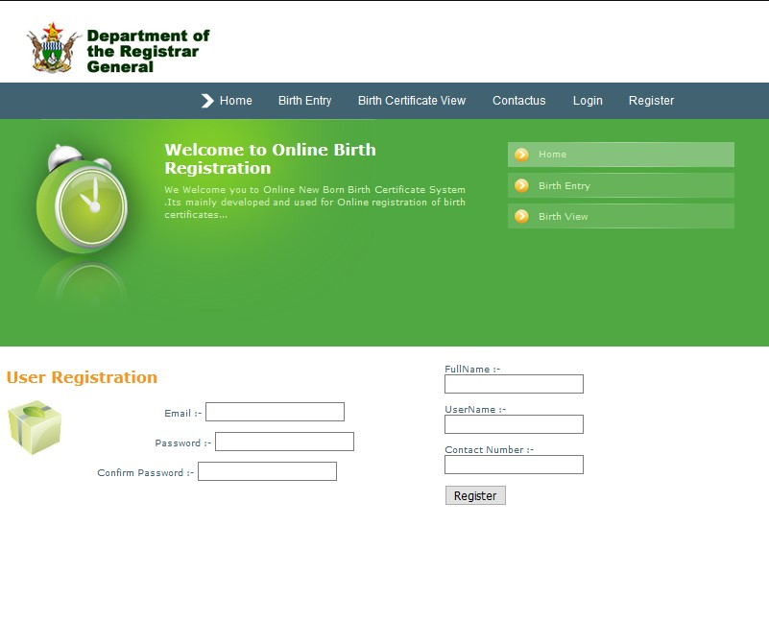

6.6.1.2 birth registration

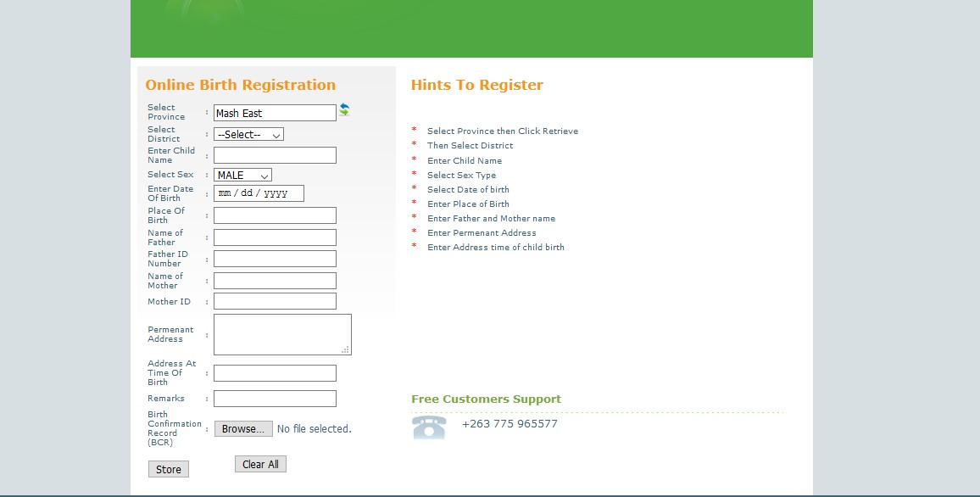

# **CHAPTER 7**

## SUMMARY, CONCLUSION & RECOMMENDATIONS

## 7.1SUMMARY

A summary of the whole research project and evaluation of the objectives is discussed in this chapter. It gives an insight to the development of the Online New Born Birth Certificate System. It also outlines and discusses the challenges faced during the development of this system and finally gives the recommendations for the future works.

From the start day of presenting the problems, faced in Birth registration

system we are delegated to take this project. An effort has been made to study birth registration system as partial fulfillment of diploma in IT. In doing the study the team has tried to follow object-oriented system analysis and design methodology.

Since the success and failure of any system depend on the gathering the right information

through different fact-finding techniques and user involvement the team has made the best effort

together requirement, after detail review and study of the existing system of Birth

registration and analysis system model has been design to reflect the new system that is supposed

to solve problem designing the Online New Born Birth Certificate System helps to maintain standalone based registration system for both customer and administrative organ.

It facilitates activities such as registration of personal data, information delivery and finally generate report beside this it avoids the problems which are related to the above activities.

In order to solve the problems existed in the past team has tried to propose a solution at least

reduce the existing problem and model the proposed system using different tools and

methodologies.

The team believe that different tools and methodologies helped as a lot in capturing real user

requirements and model the right system for the user of proposed system for their day to day

activity.

The birth registration system that we have developed is not enough for the future use so we recommended that the system should be developed using web-based basis because it is

better to access the system using web from anywhere. The system should generate the requested

certificate individually. In addition to this all the sub city system user’s /employers/ should be

trained about:

o The basics of computers

o How to Surfing the web /Internet /…

# **CHAPTER 8**

## 8.0 BIBLIOGRAPHY

**References**

_

1) Mulualem Sintayehu, Serawit Chalachew,Zelalem Ashenafi: Human Resource Management Support System for SMUC Augest 2008.Addis Ababa, Ethiopia.

2) Mohammed Ali, Shimelis Tamiru, and Bezawit Tadele: Web based Keble Information System August 2010 SMUC. Addis Ababa, Ethiopia.

3) City Governments of Addis Ababa policy, 1995e.c

4) Kelly R. (2002). Civil Registration: Vital Change -Birth, Marriage and Death Registration in The 21th Century. Presented to the Parliament of England by the Economic Secretary to the Treasury by Command of Her Majesty Cm 5355 January 2002. .St Clements House, 2-16 Coalgate, Norwich NR3 1BQ.